Registration - Design Doc

**Status:** Under review

**Created:** Nov 03, 2022

**Last Updated:** Nov 08, 2022

**Authors:** Ana Levit

**Approvers** ([✔] for LGTM)**:** ldap@ (DEV) [], ldap@ ([SRE](http://go/css-sre:shepherds-request))[], [optional] ldap@ ($PARTNERTEAM) []

**Additional Links**: [ [Shared Doc req d.pdf](https://drive.google.com/file/d/1fKQkn8He63isOvf0L3mgw0ppgdt_lz3o/view?usp=sharing), [Shared Documents - Design Doc](https://docs.google.com/document/d/1jd7uOGuQKWG18D8QNcbV64q2N91EqW6Y15Lc7c1MT7U/edit?usp=sharing&resourcekey=0-41sj9qgW3AKXqmAXce7MQA)]

# Background

Our application allows document sharing and granting permissions to users. We would also like to give each user access to their existing documents. Therefore, we want to identify the user. We want every user of the application to be registered.

In this document we will present the registration feature design.

More documentation:

* [REQUIREMENTS - Registration](https://docs.google.com/spreadsheets/d/1GZIjACup6KiMKWr5-KY7w17vnSSDoFBWcAxKcADaR6k/edit?usp=sharing)
* [User Story - registration](https://docs.google.com/document/d/13JrQjGSL2f53DrWbaKTlU1a4U0Le-80EfCtBotYR98U/edit?usp=sharing)
* [User Journey - registration](https://docs.google.com/document/d/1s4iETaHVfTRJ-khLzemLlwIadPIPc5cdj0eAPzuFoSM/edit?usp=sharing)
* [Use Cases - registration](https://docs.google.com/document/d/1PbVqv5vgPrJD2m_mvSCys8HRN0EkIsas8KHVa105vD0/edit)

# Objective

The system should support the following key requirements:

1. The input fields: “name”, “email” and “password” are required.
2. The input fields: "name", "email" and "password" need to be validated.
3. A new user can register with a unique email only.

# Overview

* Basic classes:
  + AuthenticationController - Validates input fields and controls AuthenticationService.
  + AuthenticationService - Responsible for checking if the email address already exists in the system. Creates a new user using the input fields.
  + UserRepository - Responsible for saving and reading users from the database.
  + User - Holds user data.

# Alternative Solutions

There are two registration methods that we will focus on:

1. Registration using email and password - A user is required to open an account by typing an email and password in order to use the application.
2. Registration using external services (e.g. via Google / Facebook…) - A user can register for the application by using an existing Google / Facebook account.

|  | **Registration with email and password** | **Registration with external services** |
| --- | --- | --- |
| **User’s convenience** | Users are required to manually type the required fields for registration. | Users can register faster, without inserting new credentials. |
| **Code implementation** | The developer is responsible for creating a registration page and input validation. | The developer needs to use the service API for registration and pulling the user’s information. |
| **Code safety and error prevention** | The developer implements the process himself. It may be prone to errors. He is responsible for performing tests to ensure the data integrity, reliability, input validations, exceptions handling and more. | Use of existing and proven code, developed for reliable systems. |

# The Bottom Line:

A registration process without external services is a requirement of the system. Therefore, we will implement that alternative. We are aware of the benefits of using external services, so we would like to implement this alternative as well if time permits.

# Detailed Design

## UML Diagram(class diagram):

[uml diagramm](https://drive.google.com/file/d/1FhyR72kJDHIHBBL5TtgbkRRT5dkT66LO/view?usp=sharing)

## 

## Sequence Diagram

[sequence diagram](https://app.diagrams.net/#G1hl_lC_SWzA8nOX8XMJSh9i7QYjM7v63s)

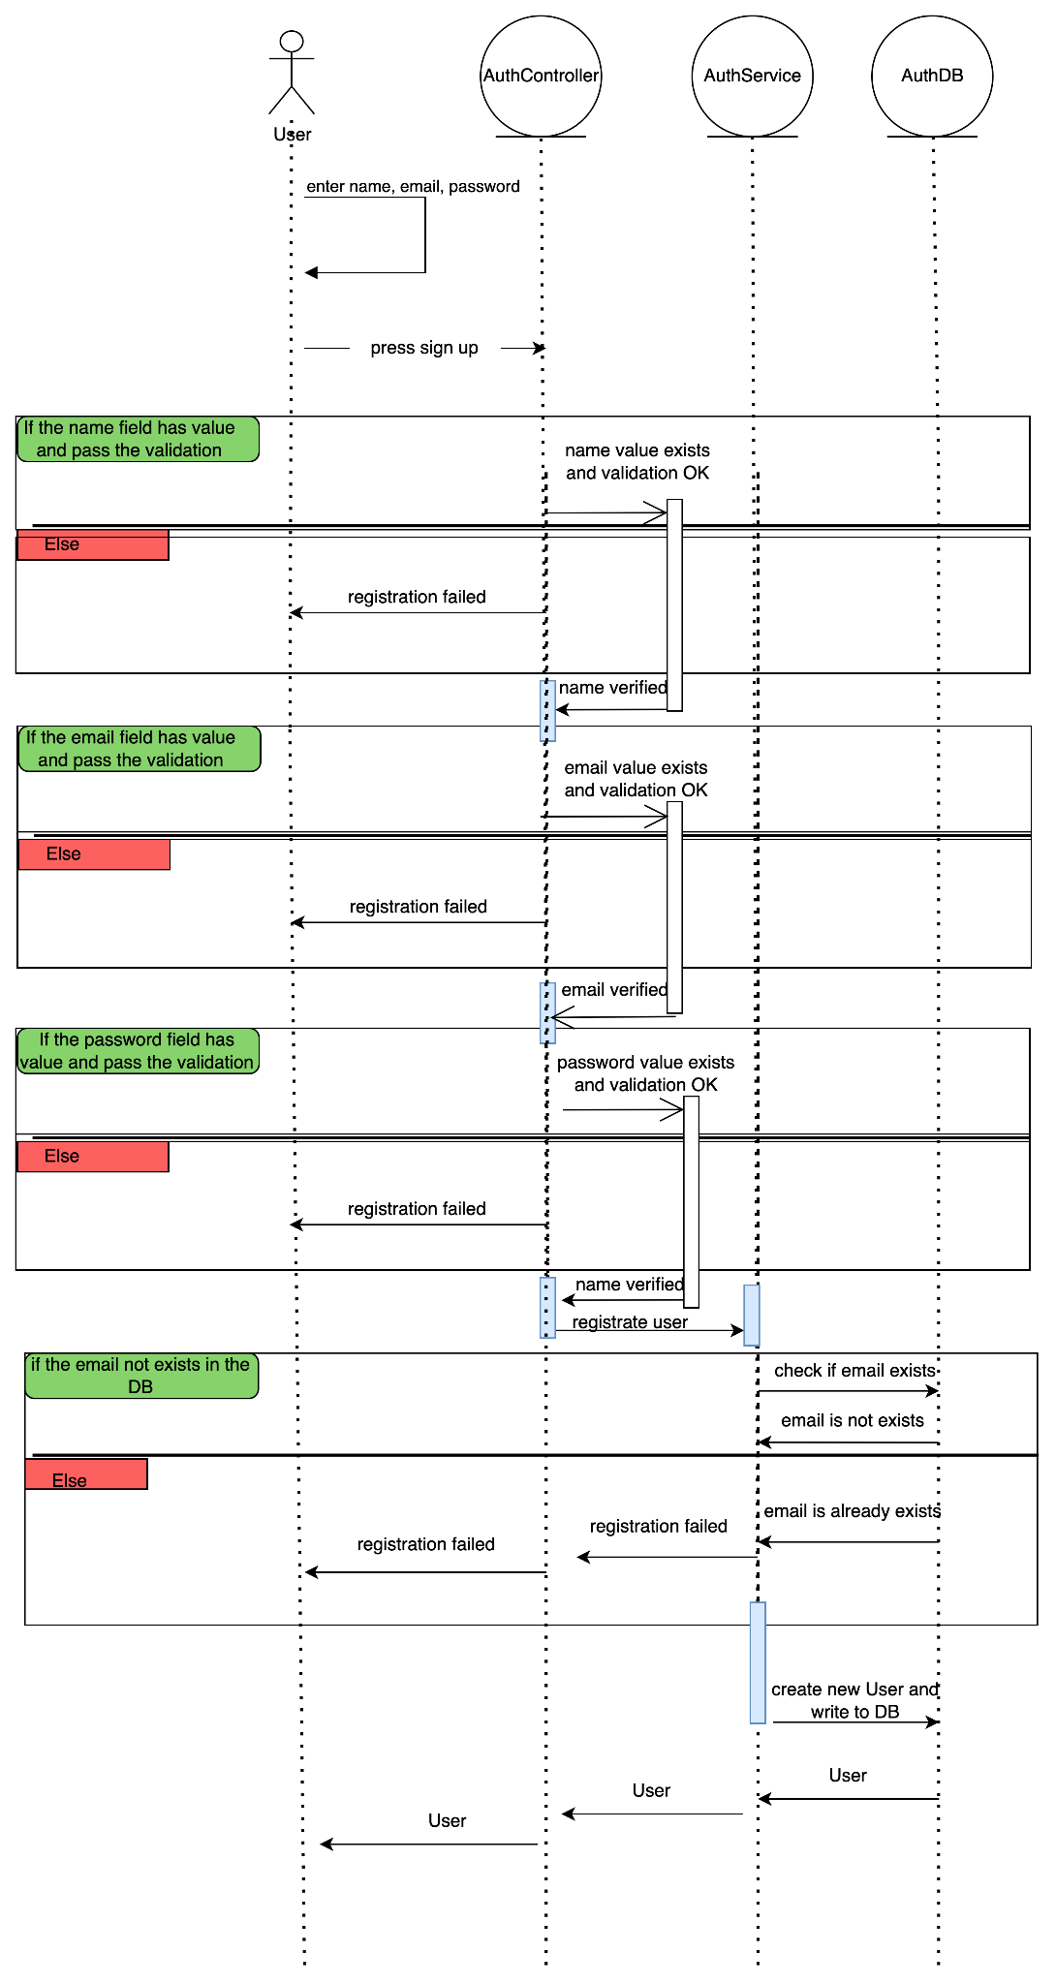

## Sketch

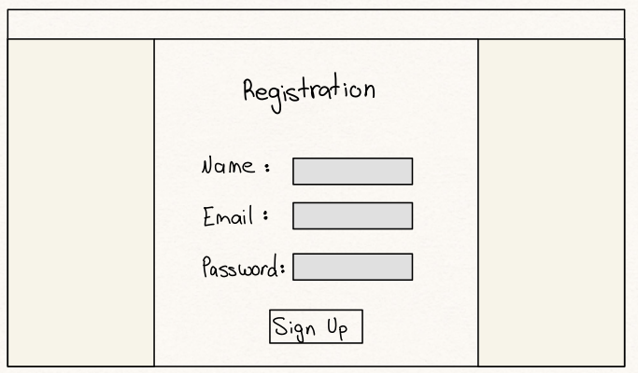

## Mockup

## 

# Testing

All regression tests will be performed automatically, each operation in the UI will have its corresponding tests in the API service, the expected coverage percentage is 85%.

[Test Cases - Registration](https://docs.google.com/spreadsheets/d/1BOaatheGw6hmBHd8eIDMSYZsuwaoCcjq-kZtpmPymYA/edit?usp=sharing)